JH3. FRANK HURLEY REAL PHOTO SERIES.

Ph Frank Hurley
F Title is in elongated tablet with pointed ends superimposed on picture.

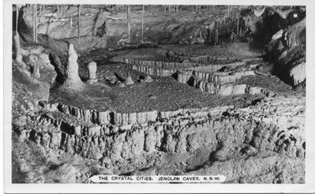

JH3.1 The Empress Grotto, Jenolan Caves, N.S.W. V K-D
(s.n.a. JH2.12)
JH3.2 The Crystal Cities, Jenolan Caves, N.S.W H K-D
Sender says "Last night Neta and I went through one of the larger caves and I was wishing you were here to play your flute. It would have been very appropriate because the cave is called the Cathedral. . . This is a marvellous place to stay and I am sorry that we have to leave."

